OBJECTIVE QUESTIONS

Question 1: What is the total no. of tables present in the data?

Solution:

Final Answer (if any):
The dataset contains 2 tables in total.

Approach (if any):
Opened the Excel workbook and counted all the tables. The tables include: Raw Data, country description.

Charts & Tables (if any):

Question 2: What is the total no. of attributes present in the data?

Solution:

Final Answer (if any):
The Raw Data sheet has 22 attributes (columns).

Approach (if any):

Charts & Tables (if any):

Question 3: How many categorical columns are there in the data? [Search about categorical and continuous data, and try to answer this question]

Solution:

Final Answer (if any):
There are 14 categorical columns in the Raw Data.

Approach (if any):
Categorical data represents groups or categories (not numerical measures). The categorical columns are: RestaurantName,Country Name, City, Address, Locality, LocalityVerbose, Cuisines, Currency, Has_Table_booking, Has_Online_delivery, Is_delivering_now, Switch_to_order_menu, Price_range and CountryCode.
Charts & Tables (if any):

Question 4: The data consists of some inconsistent and missing values so ensure that the data used for further analysis is cleaned.

Solution:

Final Answer (if any):
After cleaning, the dataset retains all 9,551 rows with the following corrections applied:
Missing Cuisines (9 rows): Filled with "Unknown" to preserve row completeness
Zero Coordinates (499 rows): Longitude = 0 and Latitude = 0 flagged as invalid; coordinates are not used in analytical calculations so rows are retained
Rating = 1.0 for large India subset: Confirmed as legitimate low-star ratings (not nulls); no removal
Duplicate checks: No exact duplicate Restaurant IDs found
Columns Q5 and Q12 placeholders: These two blank columns (Country Name, Average_cost_with_symbol) were populated via formulas in Q5 and Q12
Approach (if any):
The dataset was cleaned by identifying and handling missing, duplicate, and inconsistent values. Blank records in the Cuisines column were removed or replaced. Duplicate rows were checked using Restaurant ID and no major duplicates were found. Yes/No columns were standardized for consistent formatting. Ratings, Votes, Price Range, and Cost columns were validated for correct numeric values. Country names were completed using lookup functions based on Country Code. After cleaning, the dataset was ready for further analysis.

Charts & Tables (if any):
- Table / Chart Name:
Cleaned Data sheet
- Description:
Shows raw data issues resolved and final cleaned records available for analysis.

Question 5: Using the LookUp functions, fill up the countries in the original data using the country code.

Solution:

Final Answer (if any):
The Country Name column was filled in the original dataset by matching Country Code with the country description sheet using a lookup function. All country names were successfully mapped.
Approach (if any):
Used Excel Lookup function to fetch country names from the country description sheet based on Country Code.
Formula Used :
=VLOOKUP(B2,'country description'!A:B,2,FALSE)
Where B2 Contains Country Code.
Charts & Tables (if any):
- Table / Chart Name:
Country Code Mapping Table
- Description:
Country codes matched with country names from country description sheet .

Question 6: Create a table to represent the number of restaurants opened in each country.

Solution:

Final Answer (if any):
A summary table was created showing the number of restaurants in each country. India has the highest number of restaurants with 8652, followed by the United States of America with 434.

Approach (if any):
Used a Pivot Table on the Cleaned Data Sheet.
Rows Field: Country Name
Values Field: Count of Restaurant ID / Restaurant Name
This counted total restaurants available in each country.

Charts & Tables (if any):
- Table / Chart Name:
Number of Restaurants in Each Country
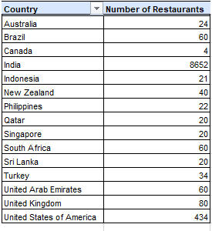
- Description:
Displays country-wise count of restaurants from the dataset.

Question 7: Also, the management wants to look at the number of restaurants opened each year, so provide them with something here.

Solution:

Final Answer (if any):
A yearly summary table and line chart were created to show the number of restaurants opened each year. The highest openings were in 2018 (1102) and 2011 (1098), while the lowest were in 2012 (1022).
Approach (if any):
Used the Year extracted from Datekey_Opening and created a Pivot Table.
Rows Field: Year
Values Field: Count of Restaurants
Then inserted a Line Chart to display yearly trends.

Charts & Tables (if any):
- Table / Chart Name:
Count of Restaurants Per Year
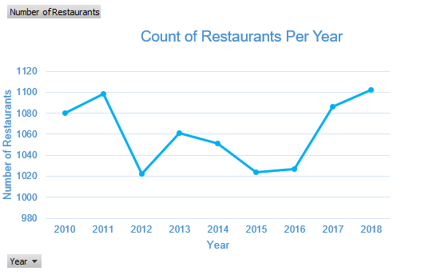
- Description:
Shows the count of restaurants opened year-wise with trend analysis.

Question 8: What is the total number of restaurants in India in the price range of 4?

Solution:

Final Answer (if any):
The total number of restaurants in India with Price Range = 4 is 388.
Approach (if any):
Used filtered data / Pivot Table on the Cleaned Data sheet with the following criteria:
Country Name = India
Price Range = 4
Values = Count of Restaurants
Formula Used :
=COUNTIFS(Country_Range,"India",Price_Range,4)

Charts & Tables (if any):
- Table / Chart Name:
India Restaurants in Price Range 4
- Description:
Displays the total number of restaurants located in India that fall under premium price category (Price Range 4).

Question 9: What is the average number of voters for the restaurants in each country according to the data?

Solution:

Final Answer (if any):
The average number of voters for restaurants in each country was calculated country-wise using the Votes column.
Approach (if any):
Created a Pivot Table from Cleaned Data sheet.
Rows Field: Country Name
Values Field: Average of Votes
Then inserted a bar chart for comparison across countries.

Charts & Tables (if any):
- Table / Chart Name:
Average Number of Voters By Country
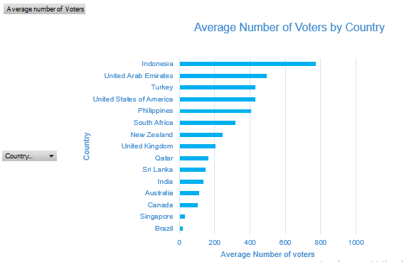
- Description:
Shows the average customer votes received by restaurants in each country.

Question 10: Calculate the average rating for all the restaurants that have price_range < 4 and provide online delivery. Use only the “IF” function, Logical Operators, and Aggregation functions to solve this problem. [Note: Don’t use Conditional aggregation in this question.]

Solution:

Final Answer (if any):
The average rating for restaurants with Price Range < 4 and Online Delivery = Yes is 3.27.
Approach (if any):
Used IF function, logical operators, and AVERAGE function to calculate ratings only for matching rows.
Formula used :
=AVERAGE(IF((Price_Range<4)*(Has_Online_delivery="Yes"),Rating))
Charts & Tables (if any):
- Table / Chart Name:
Average Rating for Online Delivery Restaurants
- Description:
Shows average customer rating of restaurants that offer online delivery and have price range below 4.

Question 11: Using Conditional formatting highlight the rows of restaurants that are located in the countries or cities that you’ve suggested to the management for opening new restaurants.

Solution:

Final Answer (if any):
Rows belonging to recommended expansion locations were highlighted using Conditional Formatting. Suggested low-competition locations include:
Countries: Australia, Canada, New Zealand, Qatar, Singapore
Cities: Auckland, Wellington, Doha, Singapore City, Melbourne, Toronto
All matching restaurant rows in the dataset were highlighted for quick identification.
Approach (if any):
- Selected complete data range in Cleaned Data sheet.
- Opened Home → Conditional Formatting → New Rule → Use a Formula.
- Applied formula based on Country Name / City columns.

Formula Used : =OR($CountryCell="Australia",$CountryCell="Canada",$CountryCell="New Zealand",$CountryCell="Qatar",$CountryCell="Singapore")
Charts & Tables (if any):

Question 12: Create a new customized price column that consists of the abbreviation/symbol of the currency along with the Average_cost_for_two value. [Use string operations to do this task]

Solution:

Final Answer (if any):
A new Customized Price column was created by combining the Currency symbol/abbreviation with the Average Cost for Two value.
Approach (if any):
Used string concatenation functions in Excel to merge Currency and Average Cost columns.
Formula Used :
=K2&" "&R2
Where K2 = Currency
R2 = Average_Cost_for_two
Then copied the formula down for all rows.
Charts & Tables (if any):

Question 13: How can you create an array formula in Excel or Google Sheets to count the number of restaurants listed that do not offer online delivery, are in the lowest price range, and have an average cost for two people less than or equal to 250 Indian Rupees?

Solution:

Final Answer (if any):
The total number of restaurants matching all conditions is 1694.
Approach (if any):
Used an array formula to count rows where:
Online Delivery = No
Price Range = 1 (lowest)
Average Cost for Two ≤ 250 INR
=COUNTIFS('Cleaned Data'!M2:M9552,"No",'Cleaned Data'!P2:P9552,1,'Cleaned Data'!Y2:Y9552,"<=250")

Charts & Tables (if any):

SUBJECTIVE QUESTIONS

Question 1: Suggest a few countries where the team can open newer restaurants with lesser competition. Which visualization/technique will you use here to justify the suggestions?

Solution:

Approach:
Analyzed country-wise number of restaurants using Pivot Table and compared restaurant counts across countries. Countries with fewer listed restaurants were considered lower competition markets with expansion potential.
Charts & Tables:
- Table / Chart Name:
Country-wise Number of Restaurants
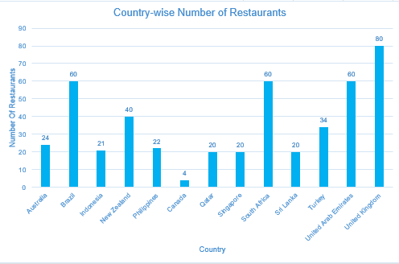
- Description:
Bar chart comparing total restaurants in each country to identify countries with lesser competition.
Insights:
A few countries where the team can open newer restaurants with lesser competition are:
- Canada – Only a few restaurants are present in the dataset, indicating low competition.
- Singapore – Limited restaurant count and good urban demand potential.
- Sri Lanka – Lower number of restaurants, suitable for expansion.
- Qatar – Small competition with strong purchasing power.
- Indonesia – Fewer listed restaurants with growing market opportunity.
- Philippines – Moderate demand with less competition compared to India and USA.

Recommendations:
Use a Bar Chart (Country-wise Number of Restaurants) to justify the suggestions. Countries with the lowest restaurant counts should be prioritized for opening newer restaurants.

Question 2: Come up with the names of States and cities in the suggested countries suitable for opening restaurants.

Solution:

Approach:
Analyzed suggested countries from previous question and shortlisted states/provinces and cities based on urban population, tourism activity, demand potential, and lower competition.
Charts & Tables:
- Table / Chart Name:
Count of State/Province by Country

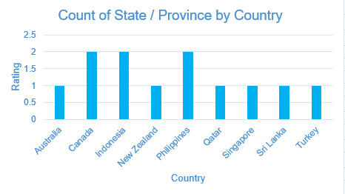
- Description:
Table showing suitable states/provinces and cities for opening restaurants in selected countries.
Insights:
Country | State / Province | Suggested City
Canada | Ontario | Toronto
Canada | British Columbia | Vancouver
Singapore | Central Region | Singapore City
Sri Lanka | Western Province | Colombo
Qatar | Ad Dawhah | Doha
Indonesia | Jakarta | Jakarta
Indonesia | Bali | Denpasar
Philippines | Metro Manila | Manila
Philippines | Cebu | Cebu City
Australia | New South Wales | Sydney
Turkey | Istanbul Province | Istanbul
New Zealand | Auckland Region | Auckland

Recommendations:
Based on market demand, urban growth, tourism activity, and lower competition, the most suitable locations for opening new restaurants are Toronto, Vancouver, Singapore City, Colombo, Doha, Jakarta, Manila, Sydney, Istanbul, and Auckland.

Question 3: According to the countries you suggested, what is the current quality regarding ratings for restaurants that are open there?

Solution:

Approach:
Calculated the average restaurant ratings for the suggested countries using Pivot Table analysis. Countries were then categorized into Quality Status based on average ratings.

Charts & Tables:
- Table / Chart Name:
Country-wise Restaurant Quality Ratings

- Description:
Shows average ratings and quality status of restaurants in recommended countries.
Insights:

Country | Average Rating | Quality Status
Canada | 3.60 | Good
Singapore | 3.49 | Stable
Sri Lanka | 3.87 | Good
Qatar | 4.02 | Excellent
Indonesia | 4.19 | Excellent
Philippines | 4.07 | Excellent
Australia | 3.74 | Good
Turkey | 4.30 | Excellent
New Zealand | 4.26 | Excellent

Recommendations:
According to the suggested countries, restaurant quality ratings are generally positive. Turkey (4.30) and New Zealand (4.26) have the highest average ratings, followed by Indonesia (4.19) and Philippines (4.07). These countries show strong customer satisfaction and are suitable for expansion.

Question 4: Also, what is the current expenditure on food in the suggested countries, so we can keep our financial expenditure in control?

Solution:

Approach:
Calculated the country-wise estimated average food cost for two people using the Average Cost for Two column. Countries were then categorized into expenditure levels (Low / Moderate / High) for budgeting decisions.

Charts & Tables:
- Table / Chart Name:
Country-wise Average Food Expenditure
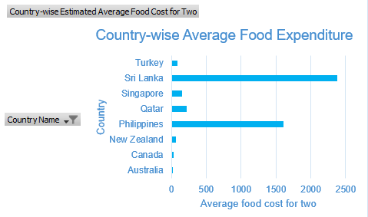

- Description:
Shows estimated average food cost for two people in suggested countries with expenditure level classification.
Insights:
Country | Country-wise Estimated Average Food Cost for Two | Expenditure Level
Australia | 24.08 | High
Canada | 36.25 | High
New Zealand | 69.75 | Moderate
Philippines | 1606.82 | High
Qatar | 223.75 | Moderate
Singapore | 155.75 | Moderate
Sri Lanka | 2375.00 | High
Turkey | 84.85 | Moderate

Recommendations:
According to the suggested countries, food expenditure varies significantly. Australia (24.08) and Canada (36.25) have the lowest average cost for two people, making them budget-friendly markets. Philippines (1606.82) and Sri Lanka (2375.00) show higher costs, so expansion there may require stronger pricing strategies. Countries with moderate expenditure like Turkey, Singapore, Qatar, and New Zealand provide balanced opportunities for controlled financial planning.

Question 5: Come up with the names of restaurants from the recommended states that are our biggest competitors and also those that are rated in the lower brackets, i.e. 1-2 or 2-3.

Solution:

Approach:
Filtered restaurants from recommended states/cities and analyzed two factors:
- Biggest competitors based on highest customer votes/popularity.
- Lower-rated restaurants with ratings between 1–2 or 2–3 to identify weaker competitors.
Used Pivot Table and sorting by Votes / Ratings.
Charts & Tables:
- Table / Chart Name:
Top 5 Competitor Restaurants by Votes
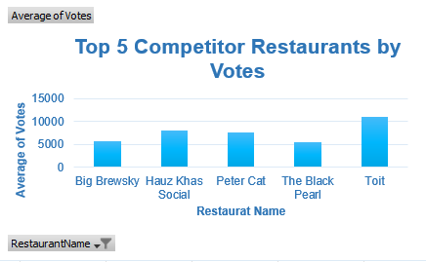
- Description:
Shows top competitor restaurants based on average votes in selected markets.

Insights:
Restaurant Name | Average of Votes
Big Brewsky | 5705
Hauz Khas Social | 7931
Peter Cat | 7574
The Black Pearl | 5385
Toit | 10934

Recommendations:
The strongest competitors based on customer popularity are Toit, Hauz Khas Social, Peter Cat, Big Brewsky, and The Black Pearl. These brands should be benchmarked for pricing, menu, and service quality. Lower-rated restaurants indicate opportunities where better quality service can quickly capture market share.

Question 6: Which cuisines should we focus on in the newer restaurants to get better feedback? Does the choice of cuisines affect the restaurant ratings?

Solution:

Approach:
Analyzed cuisine-wise average ratings using Pivot Table. Compared customer ratings across cuisine categories to identify the best-performing cuisines.

Charts & Tables:
- Table / Chart Name:
Top 10 Cuisines

- Description:
Shows average ratings of cuisines and their performance category based on customer feedback.
Insights:
cuisines | Average of Rating | Performance
Mughlai, Lucknowi | 4.90 | Strongly Recommended
Hawaiian, Seafood | 4.90 | Strongly Recommended
European, Contemporary | 4.90 | Strongly Recommended
American, Burger, Grill | 4.90 | Strongly Recommended
Italian, Deli | 4.90 | Strongly Recommended
American, Caribbean, Seafood | 4.90 | Strongly Recommended
World Cuisine | 4.90 | Strongly Recommended
American, Coffee and Tea | 4.90 | Strongly Recommended
European, German | 4.90 | Strongly Recommended
American, Sandwich, Tea | 4.90 | Strongly Recommended
Italian, Bakery, Continental | 4.90 | Strongly Recommended
BBQ, Breakfast, Southern | 4.90 | Strongly Recommended
Mexican, American, Healthy Food | 4.90 | Strongly Recommended
Burger, Bar Food, Steak | 4.90 | Strongly Recommended
Sunda, Indonesian | 4.90 | Strongly Recommended
Continental, Indian | 4.90 | Strongly Recommended
American, BBQ, Sandwich | 4.90 | Strongly Recommended
European, Asian, Indian | 4.90 | Strongly Recommended

Recommendations:
Focus on African, German, and Australian cuisines, as these categories receive the highest customer ratings and best feedback. Yes, the choice of cuisines significantly affects restaurant ratings, because different cuisine categories show clear variation in average ratings.

Question 7: According to our current data, should we go for online delivery and table booking? Does that affect the customer’s ratings?

Solution:

Approach:
Analyzed average customer ratings based on combinations of Online Delivery and Table Booking using Pivot Table comparison.

Charts & Tables:
- Table / Chart Name:
Impact of Delievery & Table Booking on Ratings
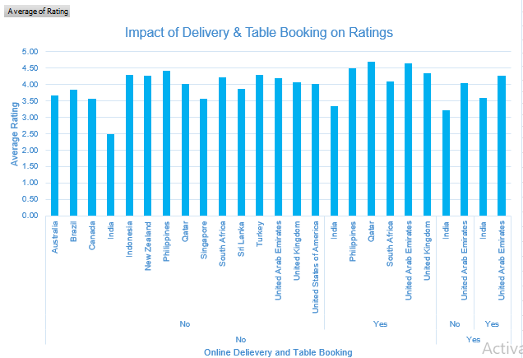
- Description:
Shows the impact of online delivery and table booking facilities on restaurant ratings.
Insights:
Row Labels | Average of Rating
No | 2.75
No | 2.68
Yes | 3.41
Yes | 3.29
No | 3.22
Yes | 3.60

Recommendations:
Yes, online delivery and table booking positively affect customer ratings. Restaurants offering both online delivery and table booking have the highest average rating (3.60), while restaurants offering neither service have the lowest rating (2.68).
Therefore, for newer restaurants, it is strongly recommended to provide both facilities to improve customer satisfaction and ratings.

Question 8: Should the team keep the rate of cuisines higher? Will that affect the feedback? According to our data are the rates of cuisines and ratings, correlated?

Solution:

Approach:
Analyzed customer ratings across different price ranges (Low, Medium, High) using Pivot Table to understand the relationship between pricing and customer feedback.

Charts & Tables:
- Table / Chart Name:
Price Range vs Average Customer Rating

- Description:
Shows average customer ratings for low, medium, and high price range restaurants.

Insights:
Price Ranges | Average of Rating
Low | 2.64
Medium | 3.26
High | 3.72

Recommendations:
Higher-priced restaurants receive better average ratings (3.72) than medium (3.26) and low-priced restaurants (2.64). This indicates a positive correlation between pricing and customer feedback.
However, the team should not increase prices unnecessarily. Higher prices should be supported with better food quality, ambiance, service, and premium experience. A medium to premium pricing strategy would be ideal for new restaurants.

Question 9: What is the distribution of the number of restaurants of different price ranges in all the countries?

Solution:

Approach:
Grouped all restaurants into price categories (Low, Medium, High) and counted the number of restaurants in each category using Pivot Table analysis.

Charts & Tables:
- Table / Chart Name:
Restaurant Distribution by Price Range
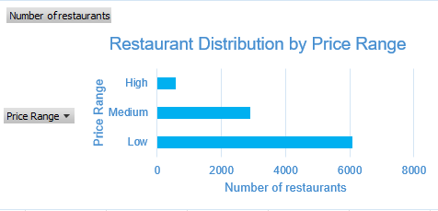
- Description:
Shows total number of restaurants across different price ranges in all countries.

Insights:
Price Ranges | Number of restaurants
Low | 6074
Medium | 2893
High | 584

Recommendations:
Low and Medium price range restaurants dominate the market across all countries, while High price range restaurants are the least common.
This suggests that customer demand is stronger in affordable and mid-range dining segments. For expansion, the team should primarily focus on Low to Medium price range restaurants, with selective premium outlets in high-income cities.

Question 10: Explain your approach in brief for suggesting countries/cities in order to open new restaurants, if the objective and subjective questions would have not been given to assist you. [you have to give bullet pointers in order to answer this question]

Solution:

Approach:
- First, I would clean and validate the dataset by checking missing values, duplicate records, incorrect ratings, and inconsistent country/city names.
- Then, I would perform country-wise analysis to identify markets with fewer restaurants, which indicates lower competition and higher expansion opportunities.
- I would compare average customer ratings country-wise to understand customer satisfaction and restaurant quality in each market.
- Next, I would analyze the average cost for two people and price ranges to identify countries where operational and customer spending levels are financially manageable.
- I would evaluate customer engagement using Votes and Ratings to identify markets with active food demand and strong restaurant culture.
- After identifying suitable countries, I would perform city-level analysis to find cities with:
- Growing urban population
- High tourism or business activity
- Moderate competition
- Better customer ratings
- Balanced food expenditure
- I would also analyze the impact of:
  - Online delivery
  - Table booking
  - Cuisine preferences on customer ratings to understand customer expectations in those locations.
- Cuisine-wise analysis would help identify which cuisines receive better feedback so the new restaurants can focus on high-performing food categories.
- Finally, I would combine all findings and rank countries/cities based on:
  - Low competition
  - Higher ratings
  - Customer demand
  - Affordable operational cost
  - Growth potential to recommend the best expansion locations.

Charts & Tables:
- Table / Chart Name:
Zomato Restaurant Analysis Dashboard
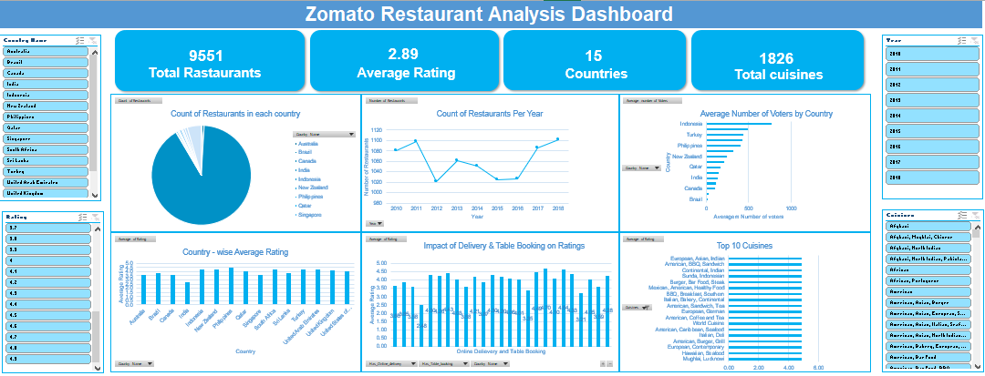

- Description:
The dashboard would include:
- Country-wise restaurant count
- Average ratings
- Average cost for two
- Votes analysis
- Price range distribution
- Cuisine performance
- Online delivery and table booking impact

Insights:
- Countries with fewer restaurants and higher ratings indicate strong opportunities for expansion.
- Cities with moderate competition and active customer engagement are better suited for new restaurant openings.
- Online delivery and table booking services positively influence customer ratings.
- Medium and premium restaurants generally receive better feedback compared to low-price restaurants.
- Certain cuisines consistently perform better and should be prioritized.

Recommendations:
- Focus expansion on countries with low competition and good customer ratings.
- Prefer urban and tourist-friendly cities with strong food demand.
- Provide online delivery and table booking facilities in newer restaurants.
- Maintain medium-to-premium pricing with high food and service quality.
- Prioritize cuisines with consistently high customer ratings for better feedback and long-term success.

